**Azure Fundamentals (Az-900)**

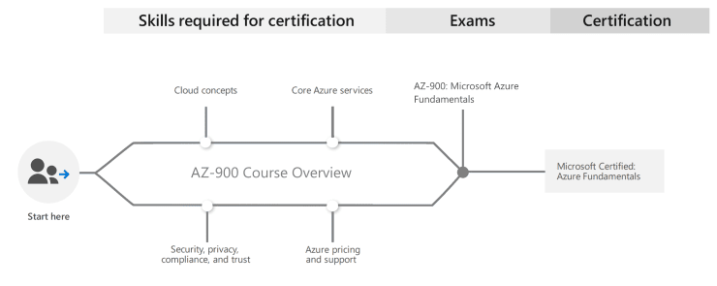

**Cloud Computing and Vocabulary**

* **Cloud computing** is a service, which offers customers to work over the internet. It simply states that *cloud computing means storing and accessing the data and programs over the internet rather than the computer’s hard disk*.
* The data can be anything such as music, files, images, documents, and many more.

**TYPES OF CLOUD COMPUTING**

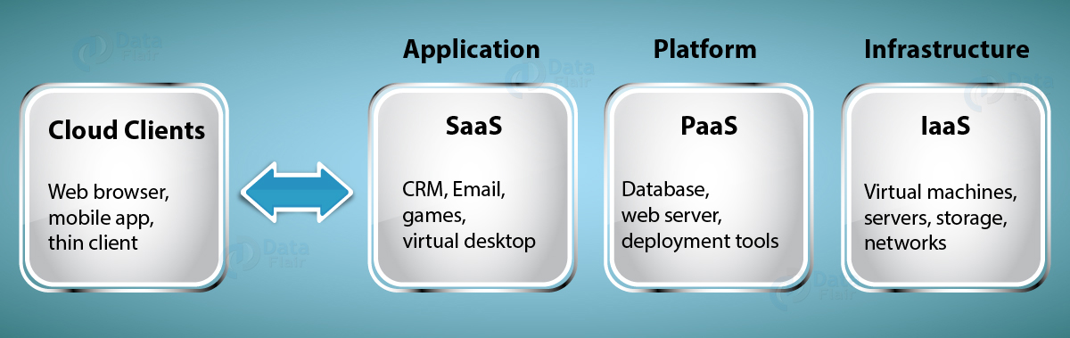

i) **SaaS :**

* **SaaS** stands for Software as a Service, providing a facility to the user to use the software from anywhere with the help of an internet connection. It is also known as software on demand.
* There are various benefits of the SaaS as it is economical and only the user has to pay for some of the basic costs such as licensing fees, installation costs, maintenance fees, and support fees.
* Some of the examples of SaaS are Yahoo! Mail, Hotmail, and Gmail.

ii) **PaaS** :

* **PaaS** stands for Platform as a Service. This helps the user by providing the facility to make, publish, and customize the software in the hosted environment. An internet connection helps to do it.
* The host of a PaaS has the hardware and software of its own. This frees the user from installing the hardware and software to execute a new application.

iii) **IaaS** :

* **IaaS** stands for Infrastructure as a Service. With the help of IAAS, the user can use IT hardware and software just by paying the basic price of it.
* The companies that use IaaS are IBM, Google, Microsoft, Amazon.
* For small start-ups and firms, the IaaS has the major advantage as it benefits them with the infrastructure rather than spending a large amount of money on hardware and infrastructure.
* The reason for choosing IaaS is that it is easier, faster, and cost-efficient which reduces the burden of the organizations.

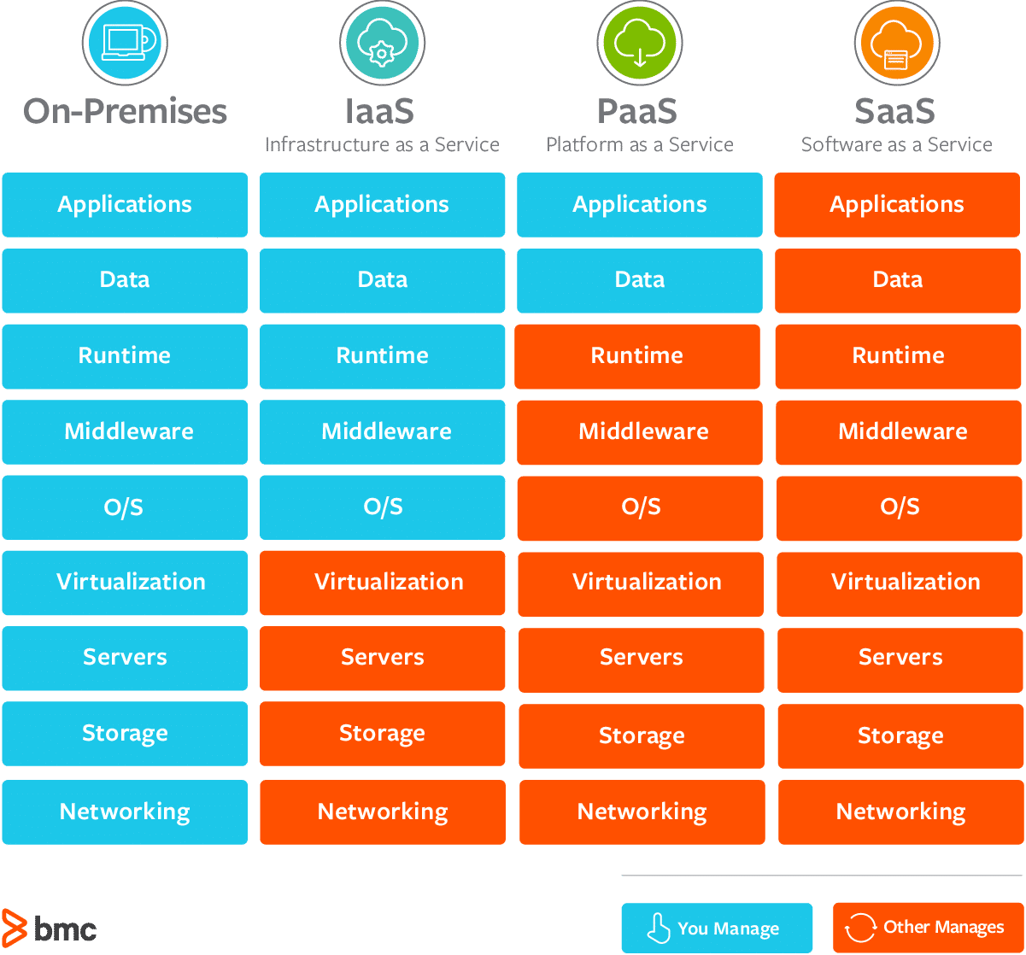

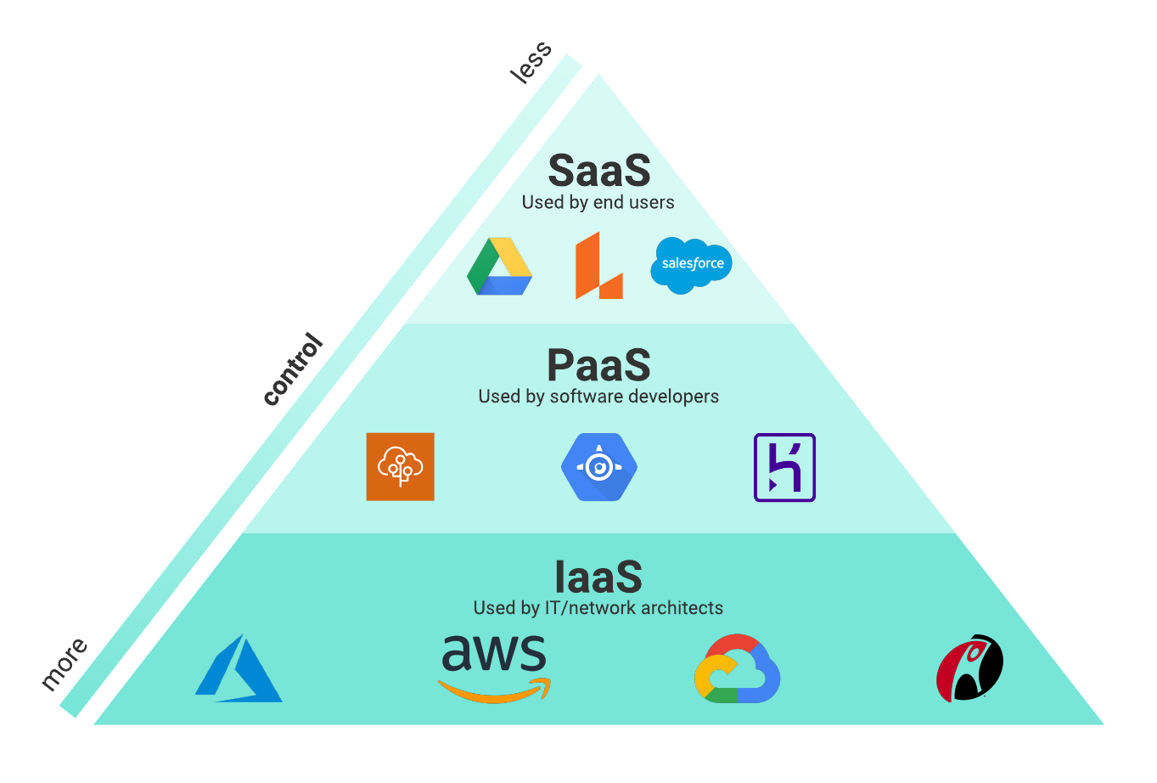

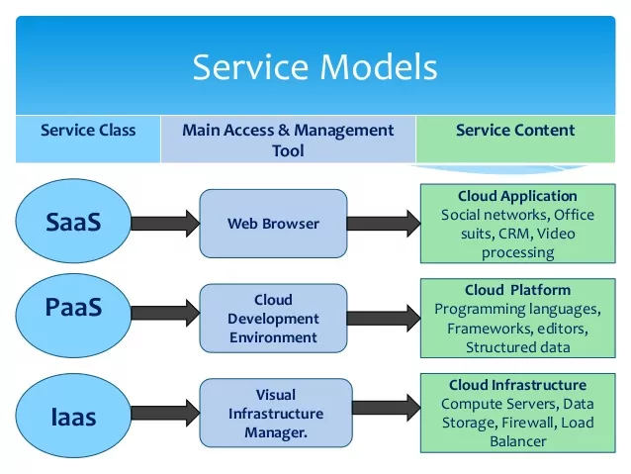

**CLOUD COMPUTING DEPLOYMENT MODELS :**

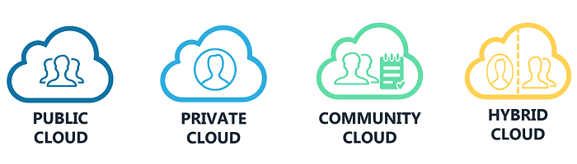

1. **PUBLIC CLOUD :**

**Public Cloud** allows systems and services to be easily accessible to the general public. The IT giants such as Google, Amazon and Microsoft offer cloud services via the Internet.

**Key Characteristics**

* Everything runs on cloud provider hardware
* No local hardware
* Some services share hardware with other customers

**Advantages**

* No CapEx (No initial investment)
* High Availability
* Agility
* Pay as you Go (PAYG) pricing
* No hardware maintenance
* No deep technical skills required

**Disadvantages**

* Not all security and compliance policies can be met
* No ownership over the physical infrastructure
* Rare specific scenarios can’t be done

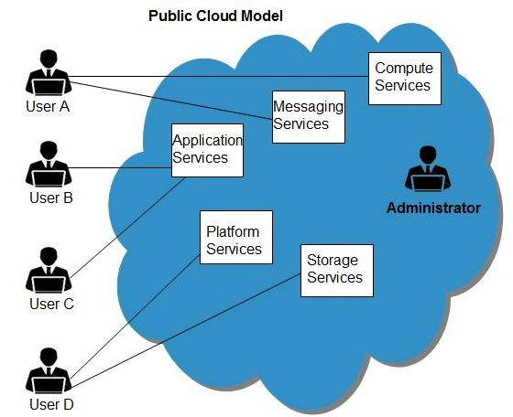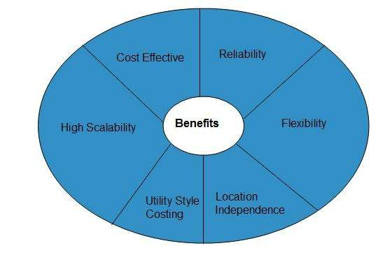

1. **PRIVATE CLOUD** :

 Private Cloud allows systems and services to be accessible within an organization. The Private Cloud is operated only within a single organization. However, it may be managed internally by the organization itself or by third-party.

**Key Characteristics**

* Everything runs on your own datacenter
* Self-service should be provided
* You maintain the hardware

**Advantages**

* Can support any scenario
* Total control over security and infrastructure
* Can meet any security and compliance policy

**Disadvantages**

* Initial investment is required (CapEx)
* Limited agility constrained by server capacity and team skills
* Very dependent on IT skills & expertise

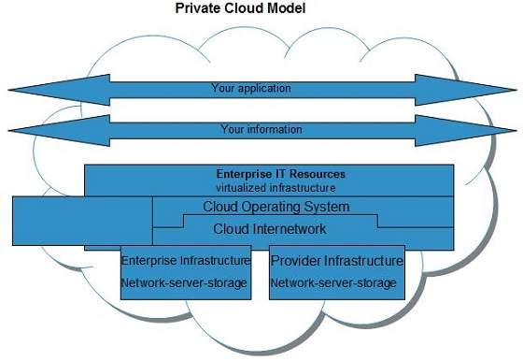 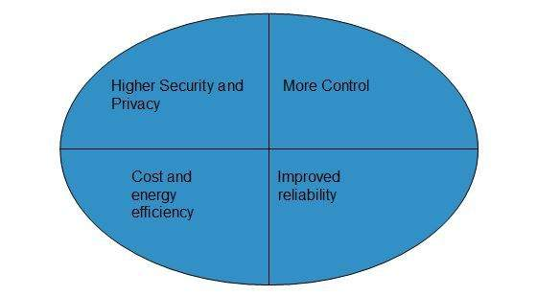

1. **COMMUNITY CLOUD** :

Community Cloud allows systems and services to be accessible by a group of organizations. It shares the infrastructure between several organizations from a specific community.

It may be managed internally by organizations or by the third-party.

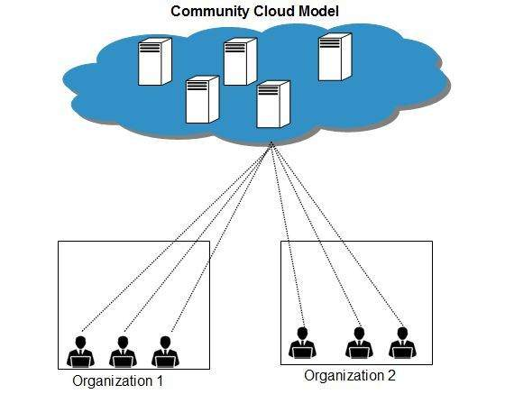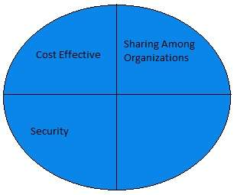

**4. HYBRID CLOUD** :

 Hybrid Cloud is a mixture of public and private cloud. Non-critical activities are performed using the public cloud while the critical activities are performed using private cloud.

**Key Characteristics**

* Combines both Public & Private cloud

**Advantages**

* Great flexibility
* You can run any legacy apps in private cloud
* Can utilize existing infrastructure
* Meet any security& compliance requirements
* Can take advantage of all public cloud benefits

**Disadvantages**

* Can be more expensive
* Complicated to manage due to larger landscape
* Most dependent on IT skills & expertise from all three models

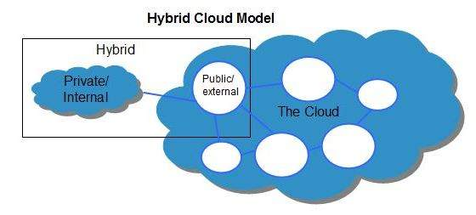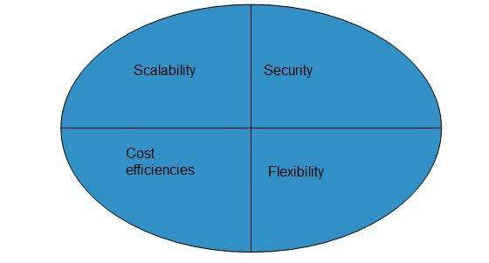

**Key concepts**

* **scalability** is the ability to scale, so allocate and deallocate resources at any time
* **elasticity** is the ability to scale dynamically
* **agility** is the ability to react fast (scale quickly)
* **fault tolerance** is the ability to maintain system uptime while physical and service component failures happen
* **disaster recovery** is the process and design principle which allows a system to recovers from natural or human induced disasters
* **high availability** is the agreed level of operational uptime for the system. It is a simple calculation of system uptime versus whole lifetime of the system.
  + **availability = uptime/(uptime + downtime)**

### Economies of Scale

The principle of economies of scale states that as the companies grow they become more effective at managing shared operations. Be that HR and hiring, taxes, accounting, internal operations, marketing, big purchases via contracts meaning better discounts, etc. etc.

Because of those, companies can save/earn more which in return allows for reduction in cost of their services to their customers. This is so called ‘price per unit’.

It’s not possible to go to 0 because in the end some underlying infrastructure needs to run to provide the services. But the larger the scale the more benefits can be passed to customers.

In fact, in the current scale, Microsoft can already offer multiple services for free due to how small a fraction of the cost it is for them.

## **CapEx vs OpEx**

**Capital expenditures** (CAPEX) are major purchases a company makes that are designed to be used over the long term.

**Operating expenses** (OPEX) are the day-to-day expenses a company incurs to keep its business operational.

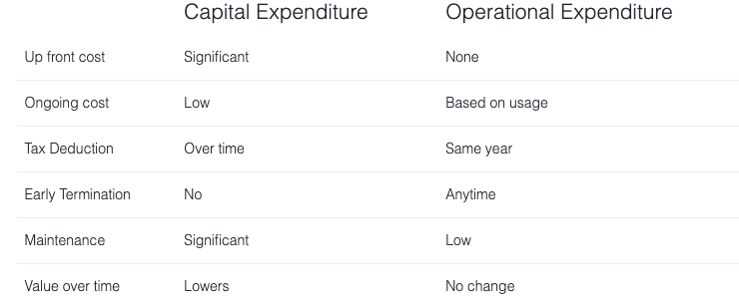

## **What is a consumption-based model?**

The consumption-based model is a **pricing model** used in the cloud so that customers are only charged **based on their resource usage**.

This model is characterized by

* **No associated upfront cost**
* **No wasted resources** as such no charges are incurred for unused resources*. Unused in this case is different per service. For instance, blob storage that stores any data is considered to be used, as it consumes the storage space. Virtual Machines that are running consume CPU, memory and other resources even if there isn’t any traffic. Hence they are considered to be used and will incur charges.
* **Pay for what you need**
* **Stop paying when you don’t**

**Consumption** is the virtual metric used to calculate how much each resource (service) in Azure was used. Each service has many smaller metrics that track its consumption to offer best possible pricing model. Those metrics are tracked on very granular level.

**Service Models responsibilities**

**As a service** means which party will manage the particular layer and all the layers below.

* **Software** layer consists the application (application code and set) & the application data
* **Platform** layer means all the supporting software and the operating system required to host the application
* **Infrastructure** layer consists hardware the infrastructure and virtualization required to host the platform.

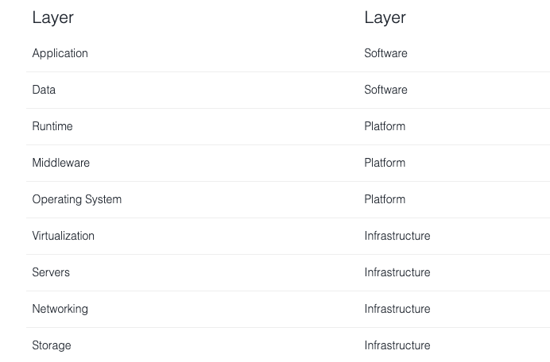

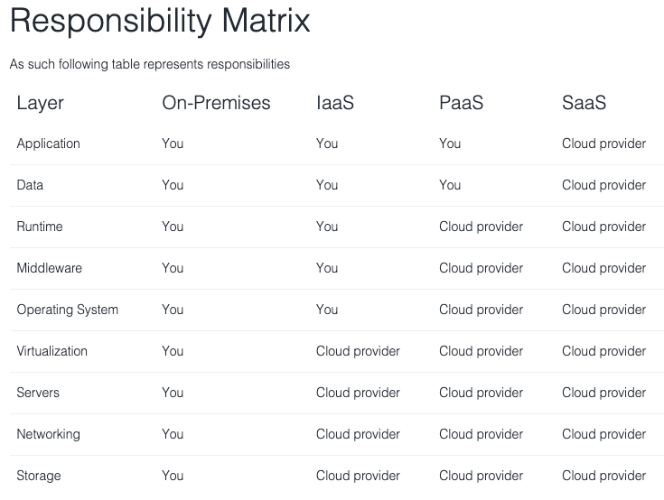

**---END---**